nanoZ Plexon Adaptor/Electrode Definitions

I. Introduction
This is a text file that defines configurations for the nanoZ corresponding to Plexon U Probe and V Probe electrodes and the adaptors that are used to connect them. Revision A adds the Samtec 64 channel adapter and electrode. This information allows the nanoZ to display a graphical representation of the selected adaptor and selected electrode, specifies the order in which the measurements are made, and specifies how the electrode sites are labeled in the nanoZ software. Note that only numeric labels are allowed for the electrode sites so the end user must be aware which site numbers correspond to the reference and ground electrodes.

There are two ways to add electrodes or adapters to your nanoZ software: individually or all of them

Add Electrodes and Adapters Individually:
- Open 09-51-A-10-A_electrodes.ini
- Go to Start menu, all programs, nanoZ, left click on Electrode Definitions
- First copy/paste the name into either “Known Electrodes” or “Known Adapters” at the top, where all of them are listed from 09-51-A-10-A_electrodes.ini into electrodes.ini
- Then you need to copy the lines of text corresponding to the electrode or adapter and bracketed by
“;-----------------------“ into the sections further down in the text file.

Add All Electrodes and Adapters:
**This will overwrite any electrodes or adapters that are in your current file**
1. Go to Start menu, all programs, nanoZ, right click on Electrode Definitions and select Open file location.
Typically C:\Users\Username\AppData\Local\nanoZ (where Username will vary from person to person)
2. Rename electrodes.ini to electrodes.old
3. Paste 09-51-A-10-A_electrodes.ini into the folder
4. Rename 09-51-A-10-A_electrodes.ini to electrodes.ini

After making changes to the electrode definitions, you can either close and open the nanoZ software or select File – Reload definitions. The text file 09-51-A-10-A_electrodes.ini defines the following electrodes and adaptors:

Adaptors:
8o50
16o50
24o50
16V
32V
Samtec 64 ch

Electrodes:
PLX 8CH UPROBE SINGLE
PLX 8CH UPROBE STEREOTRODE
PLX 8CH UPROBE TETRODE
PLX 8CH VPROBE
PLX 16CH UPROBE SINGLE
PLX 16CH UPROBE STEREOTRODE
PLX 16CH UPROBE TETRODE
PLX 16CH VPROBE
PLX 24CH UPROBE SINGLE
PLX 24CH UPROBE STEREOTRODE
PLX 24CH UPROBE TETRODE
PLX 24CH VPROBE

PLEXON 12-21-Q-06-F SEAF CARIER

II. Adaptors
All adaptors are designed as though you are looking at the end of the cable connector that plugs into the electrode (looking at the female connector). So pin 1 is located in the top right of each adaptor, except the Samtec 64 channel one. The order of the channels that are tested is listed for each adaptor below. Note that not all electrodes will physically have separate implanted wires for each of the channels (ex. Two ground connections may go to one ground wire).

Adaptor Definitions (the channel numbering does not show up in the nanoZ software):
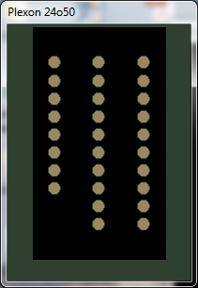
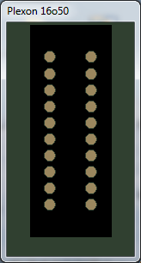
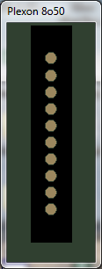

1
2
3
4
5
6
7
8
33 (R1)
25-32, 35 (G1)
9
10
11
12
13
14
15
16
(R2) 34
(G2) 36
17
18
19
20
21
22
23
24
1
2
3
4
5
6
7
8
17 (R1)
18 (G1)
9
10
11
12
13
14
15
16
(R2) 19
(G2) 20
1
2
3
4
5
6
7
8
(R) 9
(G) 10

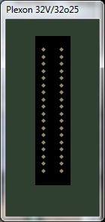
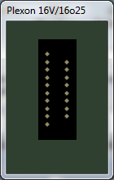
35 (G1)
1
2
3
4
5
6
7
8
9
10
11
12
13
14
15
16
33 (R1)
(R2) 34
17
18
19
20
21
22
23
24
25
26
27
28
29
30
31
32
(G2) 36
1
2
3
4
5
6
7
8

(R) 17
9
10
11
12
13
14
15
16
(G) 18

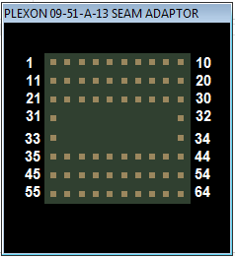

III. Electrode Definitions:
A. Eight channel electrodes
The electrode sites are tested in the order shown below. Refer to the U Probe and V Probe documentation to learn how the jumpers configure reference and ground. Reference is always a small dot in the top right of the electrode, and ground is a large dot in the top right of the electrode.

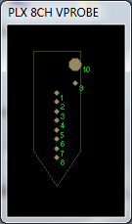
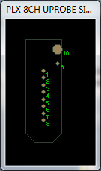
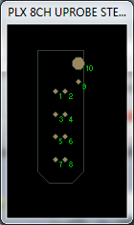
PLX 8CH UPROBE SINGLE
PLX 8CH UPROBE STEREOTRODE
PLX 8CH UPROBE TETRODE
PLX 8CH VPROBE

Channels 1-8 on the probe appear as channels 1-8 in the nanoZ software.

The reference electrode will appear as channel 9 in the nanoZ software.

The ground electrode will appear as channel 10 in the nanoZ software.

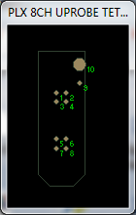

B. Sixteen channel electrodes
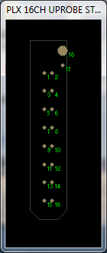
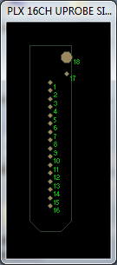
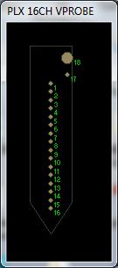
PLX 16CH UPROBE SINGLE
PLX 16CH UPROBE STEREOTRODE
PLX 16CH UPROBE TETRODE
PLX 16CH VPROBE

Channels 1-16 on the probe appear as channels 1-16 in the nanoZ software.

The reference electrode will appear as channel 17 in the nanoZ software.

The ground electrode will appear as channel 18 in the nanoZ software.

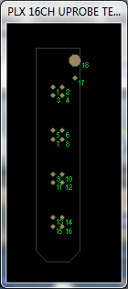

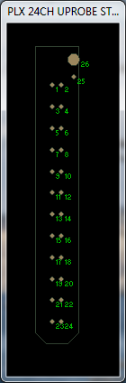
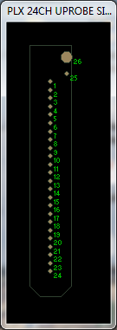
C. 24 Channel electrodes

PLX 24CH UPROBE SINGLE
PLX 24CH UPROBE STEREOTRODE
PLX 24CH UPROBE TETRODE
PLX 24CH VPROBE

Channels 1-24 on the probe appear as channels 1-24 in the nanoZ software.

The reference electrode will appear as channel 25 in the nanoZ software.

The ground electrode will appear as channel 26 in the nanoZ software.

You will notice that for the 24o50 adaptor and the 24 channel U Probes, ground is repeatedly measured. This is necessary because some 24 channel U Probes and V Probes use the same connector as other 32 channel electrodes. In order to allow the 24 or 32 channel adaptors to be connected to the 24 channel U Probes and V Probes, as well as preserve the functionality of the 32 channel adaptors with true 32 channel electrodes, an extra 8 ground measurements are made. This basically makes the 24 channel adaptor, U Probes, and V Probe look like 32 channel adaptors and electrodes to the software. Similarly, sometimes reference is measured twice to allow adaptors to be used with electrodes that have two separate reference electrodes.

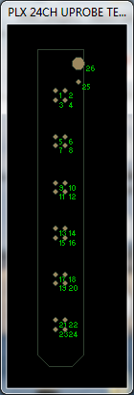
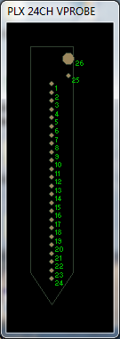

D. 64 Channel electrodes

PLEXON 12-21-Q-06-F SEAF CARIER

Channels 1-64 are measured by the nanoZ sequentially. The graphical representation is of the holes on the bottom of the modules. These are soldered to the larger carrier. The carrier is then connected to the Samtec-to-nanoZ adapter. The first 32 channels are on the front side of the carrier, and the second 32 channels are on the back side of the carrier. They are all displayed at the same time in the nanoZ graphic though because there is no way to show them separately. The microwires that are connected to the holes can have a different physical orientation once they are implanted.

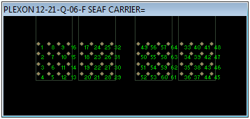

About Plexon Inc
Plexon is a pioneer and leading innovator of custom, high-performance data acquisition, behavior and analysis solutions specifically designed for scientific research. We collaborate with and supply thousands of customers including the most prestigious neuroscience laboratories around the globe driving new frontiers in areas including basic science, brain-machine interfaces (BMI), neurodegenerative diseases, addictive behaviors and neuroprosthetics. Plexon offers integrated solutions for in vivo neurophysiology, optogenetics, and behavioral research – backed by its industry-leading commitment to quality and customer support. For more information, please visit www.plexon.com.
Sales Support
For Sales Support, email info@plexon.com or call +1 (214) 369-4957.
Technical Support
If after reviewing this document, you would still like to access Plexon’s Technical Support, we are available via several communication channels. You are invited to reach us through email, on the phone.
EMAIL | PHONE
support@plexon.com | 8:30 a.m. to 5:00 p.m. Central Time  +1 (214) 369-4957

